
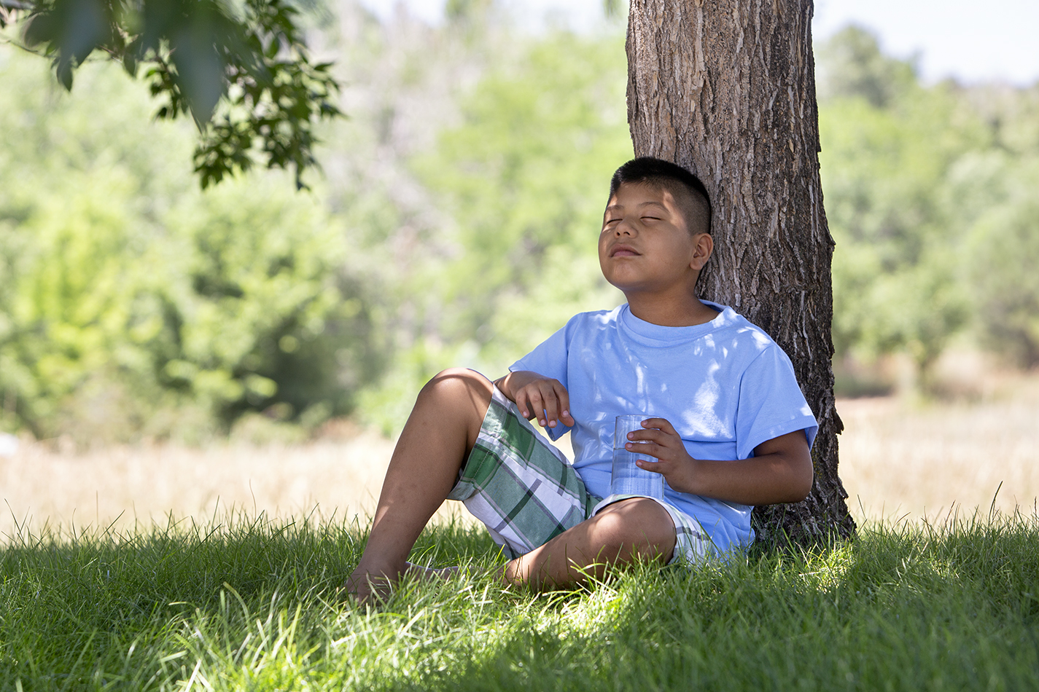

January 2019

Because January is a time for new beginnings, let’s go back to the very beginning. Genesis, the Bible’s first book, starts with the words “In the beginning, God created the heavens and the earth.” Over six days, God made the entire world and everything in it.

Young children are usually intrigued by the creatures God fashioned to fill the air, water, and land. Most children’s Bibles colorfully depict the variety of marvelous animals God made. Yet it’s also important to emphasize God’s final creative act before resting: making people in his own image.

Humans weren’t just God’s grand experiment; instead, our Creator has a specific purpose and plan for each of his beloved children. As kids grow, they often wonder, “Why am I here?” or “What am I supposed to do with my life?”

The main reason God created people is because he wants to have a relationship with us. Our ultimate purpose is to love God and to believe in his Son, Jesus. By growing closer to God through his Word and through prayer, we can begin discovering what specific plans he has in store for our lives. As Ephesians 2:10 (NLT) says, “We are God’s masterpiece. He has created us anew in Christ Jesus, so we can do the good things he planned for us long ago.”

Read on for some active experiences that reinforce what God made and how he created us with a purpose.

God Created You With a Purpose


POWERSOURCE
ASK JESUS:
1. To help your children realize they are wonderfully made—in God’s image.
2. To remind family members they each have a God-given purpose.
3. To reveal his plans for each person, no matter his or her age.

Church Logo and
Information
Ken Mawr UP Church
1760 Pine Hollow Road
McKees Rocks, PA 15136
www.kenmawrchurch.org
412-331-2863

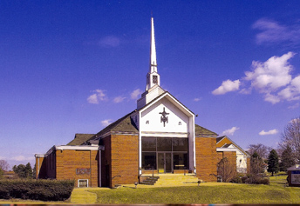

TEACHABLE
MOMENTS

God’s Plan Boxes

You’ll need a Bible, one medium-size box per family member, wrapping paper, and decorating supplies such as markers and stickers. Decorate your boxes, making sure they still open.
Afterward, say: Let’s store in these boxes reminders of how God uses challenges to do great things in our lives. For example, you can add a ribbon from a sports event to remind you of the satisfaction that comes from practice. Or you can include a note of encouragement you receive.
Read aloud Psalm 33:11. Ask: What does this Bible verse say about God’s plans for you? What are some amazing things God has already done in your life?
Read aloud Psalm 40:4-5. Ask: Why do you think God takes the time to make plans for each of us? Why is it important to follow God’s plan?
Close in prayer, thanking God for making each of you “on purpose.”

Everything God Made Is Good!

After creating the world, God called it good. What an understatement! In fact, God’s work is incredible! Whether you look at creation up close or from far off, you must admit it’s amazing. God thought up the tiniest bug and the largest planet. And he created people—not merely to populate his world but to share him and his love with others. We’ve never needed God’s love more. Although human sinfulness marred his perfect world, God never gives up on us. Instead, he faithfully continues working through his imperfect creations to fulfill a perfect plan.

“For I know the plans I have for you,” says the Lord. “They are plans for good and not for disaster, to give you a future and a hope.”
—Jeremiah 29:11

Time to Create! Make clay by squishing together for five minutes 1 cup flour, 1/3 cup salt, and 1/3 cup tap water. Create a never-seen-before animal or plant. Name the creation and compare it to something God made in Genesis 1.
Wonderfully Made Read aloud Psalm 139:14. Call out body parts, and have family members name good uses for each one. For example, “God gave me hands to help others,” or “I use my ears to listen to teachers.” Then hold hands and repeat the first part of the verse four times.

Creation Snack Mix Make a treat to represent what God created:
Day 1: Light and dark (mini Oreo cookies)
Day 2: Sky and ground (Frosted Mini-Wheats cereal)
Day 3: Trees, grass, and flowers (stick pretzels, green and red M&M’s candies)
Day 4: Sun, moon, and stars (orange and yellow M&M’s candies)
Day 5: Birds and fish (Goldfish crackers)
Day 6: People, plus all animals that walk on the ground (animal cookies)
Day 7: God rested (marshmallow “pillows”) and saw that everything he made was good (enjoy!).
Follow God’s Plans Cut a large red paper heart into 10 pieces. Put each piece in a separate envelope. Tape five envelopes in easy-to-see places and five in hard-to-see places (inside cabinet doors or under chairs). Tell family members to search for 10 envelopes while following your traveling instructions (hop, tiptoe, crawl, etc.). Lead the group to all the envelopes, then assemble the pieces. Ask: “How does God show us his love?” Read aloud Jeremiah 29:11. Say: “God loves us and has good plans for us. If you hadn’t followed my instructions, you wouldn’t have found all these pieces. Let’s follow God so we don’t miss the great things he has planned for us!”

A Perfect Plan Display a globe. Say: “We can see only a small part of the world at a time, but God always sees his entire creation—and has a plan for every creature.” Ask what jobs God gave cows, dogs, and mosquitoes. Say: “Although they’re pesky to us, mosquitoes even have a place in God’s world, as food for bats and birds.” Read aloud Psalm 89:11. Say: “This Bible verse reminds us that God has a plan for everything he made—even mosquitoes!” Put your hands on the globe and pray, thanking God for the whole world.



MOVIE

Title: A Dog’s Way Home
Genre: Adventure, Family
Rating: PG
Cast: Bryce Dallas Howard, Ashley Judd, Edward James Olmos
Synopsis: In this movie, based on a novel by W. Bruce Cameron, Bella the pitbull travels 400 miles to return to Lucas, her owner. The loyal dog must survive the Colorado wilderness to make it back to her “person.”
Our Take: As with Cameron’s book and movie A Dog’s Purpose, expect this to tug on your heartstrings. The perilous situations may be tough for some children to watch. Discuss the concepts of being “lost and found”—especially how Jesus searches for us, his lost sheep. Also talk about what it means to have unwavering devotion.


TV

Title: Let’s Go, Luna!
Network: PBS Kids
Synopsis: This new TV series for kids ages 4 to 7 introduces viewers to cultures throughout the world. As three friends (a wombat, a butterfly, and a frog) travel with their parents’ performance troupe, Luna the Moon helps them learn about each region and its people, food, music, and folktales. Each episode contains two 11-minute stories.
Our Take: PBS continues to make education fun and age-appropriate. This series encourages curiosity about our diverse world and teaches basic social-studies concepts. It also shows children the importance of global citizenship and cultural appreciation—lessons you can reinforce when you travel as a family, even close to home.

MEDIA MADNESS

CULTURE
& TRENDS
Getting Organized Nannies are so 2018! More parents are using “family assistants” to help with childcare, household duties, driving, and schedule management. Two moms who launched the family-assistant service Nest Easy say meal prep is one of their clients’ biggest needs. (various websites)

Slime Is Here to Stay Love it or hate it, the slime craze is more than a fad. Forecasters say the glue-hungry goop “has legs” because caregivers seek out tactile, educational activities for kids. (cen.acs.org)

QUICK STATS
Back-to-School, Winter Edition If you ran out of ideas to keep kids busy over Christmas break, you’re not alone. Last year, 58% of parents said they wished summer break were over after 13 days. (businesswire.com)

Soup’s On—Use Care! Almost 10,000 U.S. children receive burns from instant-soup products every year. (aap.org)

On the Horizon? Although only about 5% of families own a virtual reality headset, 62% of parents believe VR will prove educational for their kids. (smallbiztrends.com; commonsensemedia.org)

Games, Podcasts & Apps

Super Mario Party
This Nintendo Switch game offers the original board-game-style play of Mario Party but with upgraded strategic elements. It also has 80 skill-based mini-games and Toad’s Rec Room, which lets you pair up two gaming systems. Up to four people can play. Rated E, with mild cartoon violence.
Grimm, Grimmer, Grimmest
This podcast from Pinna, an ad-free app for ages 3-8, features Grimm fairy tales with a twist. A classroom of grade-schoolers tries to predict plot points, reacts to enchanting creatures, and challenges the tales’ logic. Reviews call the podcast fun, daring, and highly interactive.
Bully Alert
Researchers developed this free Android app to combat cyberbullying. The app tracks a child’s public Instagram account for signs of bullying and alerts parents within two hours of the onset of any problems. Parental feedback helps the app become personalized over time.

This page is designed to help educate parents and isn’t meant to endorse any movie, music, or product. Our prayer is that you’ll make informed decisions about what your children watch, read, listen to, and play.

January

SUNDAY | MONDAY | TUESDAY | WEDNESDAY | THURSDAY | FRIDAY | SATURDAY
 |  | 1  New Year’s Day | 2  Jam 6:30-7:30 | 3 | 4 | 5
6  Sunday School 9:45 | 7 | 8 | 9  Jam 6:30-7:30 | 10 | 11 | 12
13  Sunday School 9:45  Youth Group  6pm | 14 | 15 | 16  Jam 6:30-7:30 | 17 | 18  Winterville  Youth Retreat | 19  Winterville  Youth Retreat
20  Sunday School 9:45 | 21  MLK Jr. Day | 22 | 23  Jam 6:30-7:30 | 24 | 25 | 26
27  Sunday School 9:45  Event 2.0  MS/HS  6-9pm | 28 | 29 | 30  Jam 6:30-7:30 | 31

