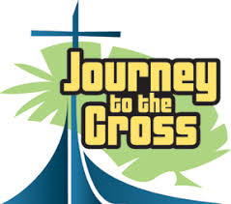
Journey to the Cross
Friday, March 30
9:00 -11:30am
Ages: 4 year old preschool – 6th grade
5th & 6th graders will participate in
separate activities.
Snack will be provided.

Name___________________________________

Grade: _______ Date of Birth:________________

Home Phone #___________Cell #_____________

Parent or Guardian’s Name:___________________

Parent’s Email Address:_____________________

Address:________________________________

______________________________________

Emergency#:____________________________

Allergies or conditions:_____________________

_____________________________________

Please place in door pocket of Sunday School Office

